Appendix

Technical Review Form Questions – each rating is then backed up by a text box

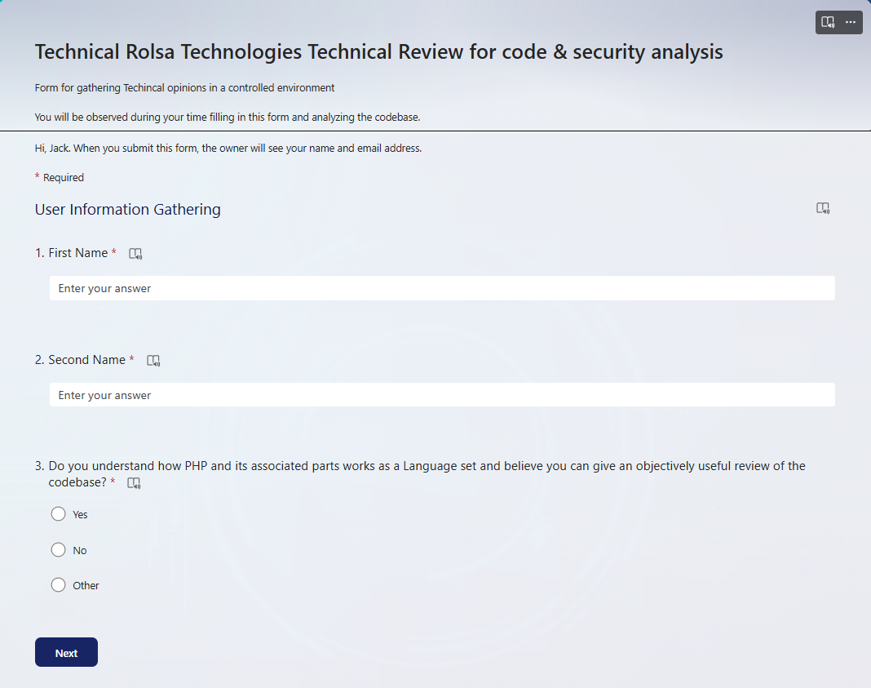

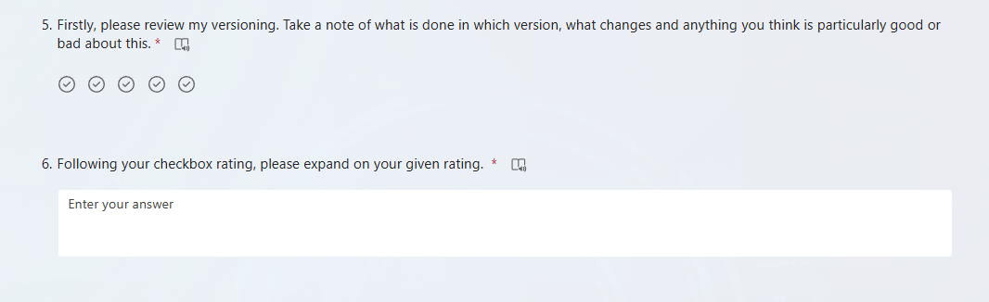

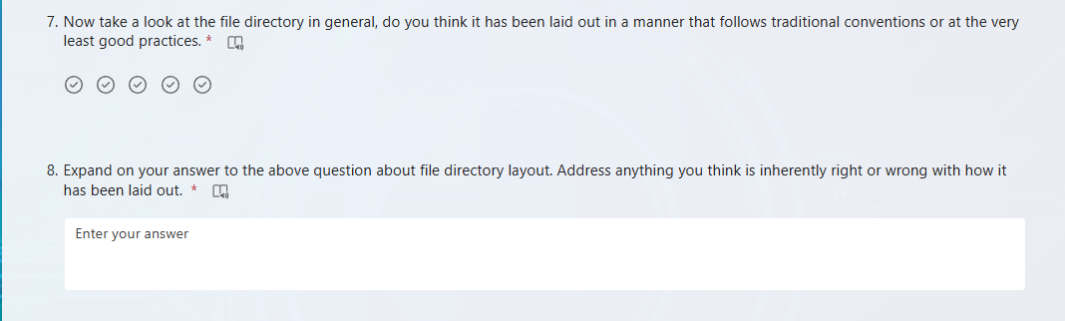

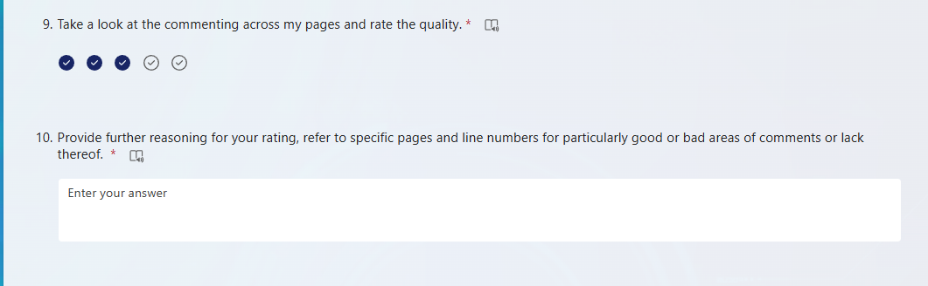

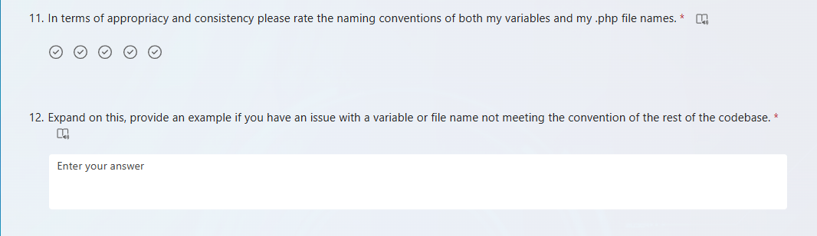

**Non-Technical Review Screenshots**